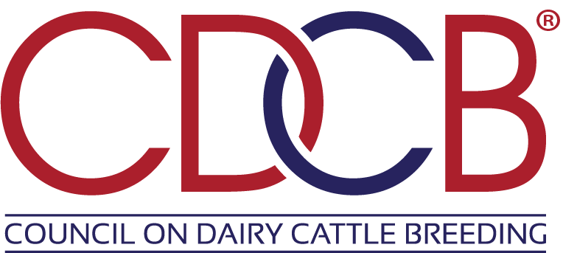
Technical Project Manager
Location: Bowie, MD (Remote work may be considered)
Reports To: Chief Technology Officer

Position Overview
The Council on Dairy Cattle Breeding (CDCB) is seeking a Project Manager to lead cross-functional planning and delivery of strategic software and data initiatives supporting CDCB’s technology roadmap. This role will partner closely with engineering leadership, product stakeholders, and business teams to drive execution across complex technical projects involving legacy migrations, cloud platforms, large-scale data systems, and software development initiatives. Additionally, this role will help to grow the project management facet of our organizational culture.

The ideal candidate combines strong project and program management discipline with an understanding of modern software engineering environments, helping ensure priorities are aligned, delivery stays on track, risks are proactively managed, and teams are positioned for success.

Key Responsibilities
- Lead planning and execution of complex software, data, and infrastructure initiatives from initiation through delivery.
- Partner with engineering leadership, including Principal Engineers and Product stakeholders, to translate technical roadmaps into actionable project plans and delivery milestones.
- Manage scope, schedules, dependencies, risks, resource planning, and stakeholder communications across multiple concurrent initiatives.
- Facilitate Agile delivery processes including backlog coordination, standups, retrospectives, and release planning as appropriate.
- Coordinate cross-functional efforts involving software & cloud engineering, operations, and business stakeholders to drive alignment and execution.
- Track project progress, budgets, deliverables, and success metrics while identifying and mitigating delivery risks and roadblocks.
- Support prioritization and sequencing of initiatives involving cloud architecture, data pipelines, analytics platforms, and application development.
- Partner with technical teams supporting environments leveraging on-prem, AWS, Terraform, CI/CD pipelines, and large-scale data platforms such as Snowflake.
- Establish and improve project management standards, governance practices, documentation, and reporting processes.
- Work with other partners within the organization to establish strong and coordinated project management practices.
- Drive communication across leadership and technical teams, providing visibility into status, risks, decisions, and dependencies.
- Support partner coordination when applicable and help ensure successful implementation outcomes.
- Contribute to long-term planning efforts, helping align project execution with organizational and technology strategy.

Required Skills and Competencies
- Experience managing complex software development or enterprise technology projects in Agile or hybrid delivery environments.
- Strong understanding of software development lifecycles, engineering workflows, and modern delivery methodologies.
- Experience supporting projects involving cloud technologies, distributed systems, data platforms, APIs, or infrastructure initiatives.
- Familiarity with migration environments leveraging on-prem, cloud, Infrastructure as Code (Terraform), CI/CD practices, and large-scale data ecosystems.
- Ability to coordinate highly technical teams working in technologies such as C#, Python, Kotlin, Java, TypeScript, or similar modern stacks.
- Strong command of project planning tools and delivery reporting frameworks.
- Demonstrated ability to manage risks, dependencies, competing priorities, and shifting requirements in complex environments.
- Strong communication and stakeholder management skills, including the ability to engage both technical and executive audiences.
- Ability to bring structure, process discipline, and execution rigor while supporting collaborative, innovative engineering teams.

Preferred Qualifications
- Experience managing projects involving modernization of large-scale legacy system migrations.
- Experience managing projects involving large-scale data systems, analytics platforms, or scientific/technical data environments.
- Familiarity with genomics, agriculture, life sciences, or research-oriented organizations is a plus.
- Experience supporting product-driven or platform modernization initiatives.
- PMP, Agile/Scrum, SAFe, or related project management certifications preferred.

Education
Bachelor’s degree in Information Systems, Computer Science, Business, or related field required.
Advanced degree or relevant certifications preferred.

Ideal Candidate Profile
The successful candidate will bring:
- Technical project or program management experience supporting software engineering organizations.
- Strong delivery leadership across cloud, data, and application initiatives.
- The ability to operate as a strategic partner to engineering leadership while maintaining hands-on ownership of execution.
- A balance of process discipline, communication strength, and comfort navigating complex technical environments.

Work Environment
CDCB prefers a hybrid or in-office presence when feasible, though remote work may be considered for the right candidate. The environment is collaborative, mission-driven, and focused on innovation, data quality, and scalable technology solutions supporting the dairy industry.

About CDCB
The Council on Dairy Cattle Breeding (CDCB) provides industry-leading genetic evaluation and data services supporting dairy producers and the broader agricultural community. Technology and data are central to CDCB’s mission, making this role a key contributor to future innovation and execution.

