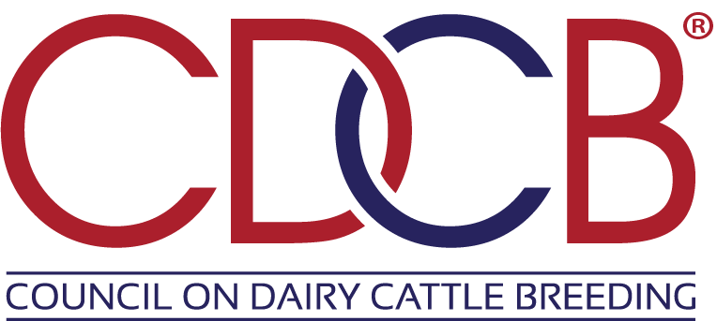

Job Title: Principal Software Engineer
Location: Bowie, MD. Remote work may be considered as well.
Reports To: Chief Technology Officer

Position Overview
The Council on Dairy Cattle Breeding (CDCB) seeks an experienced and highly skilled Principal Software Engineer to lead and shape the direction of our software development initiatives. As a Principal Software Engineer, you will be responsible for driving the design and architecture of complex systems and ensuring the technical success of major projects. You will work collaboratively with cross-functional teams to deliver scalable, high-quality solutions, while setting standards and best practices for the organization.

Key Responsibilities

Qualifications and Experience
- Lead the design and development of high-performance, scalable, and maintainable software systems.
- Architect complex software solutions and ensure technical feasibility.
- Drive the adoption of engineering best practices, coding standards, and design principles across the team.
- Provide technical leadership, fostering a culture of continuous learning.
- Collaborate with product managers, designers, and other stakeholders to define system requirements and technical specifications.
- Evaluate and recommend emerging technologies and tools to enhance the software development process.
- Participate in code reviews, ensuring high code quality, security, and scalability.
- Troubleshoot and resolve complex technical issues, acting as the go-to expert for critical problems.
- Contribute to the development of technical roadmaps and long-term strategic goals for the engineering organization.
- Lead the implementation of key features or products, ensuring deadlines and quality standards are met.
- Influence the direction of the engineering team’s culture and processes to foster innovation and collaboration.

Required Skills and Competencies

- Understanding of distributed systems and high-availability architectures on cloud-based platforms.
- Expert level experience with building and maintaining large, always-on data systems built in Kotlin/Java, C#, and JavaScript.
- Deep working knowledge of AWS managed and unmanaged services, and Infrastructure as Code.
- Expert level proficiency with large data warehouse systems such as Snowflake or Big Query.
- Knowledge of DevOps practices and CI/CD pipelines.
- Experience with performance tuning, profiling, and optimization of large-scale systems.
- Familiarity with security best practices and secure coding standards.
- Ability to learn new problem spaces and how to build processes to fit them.
- Engineer software systems to handle large volumes of data.
- Excellent written and verbal communication, with the ability to engage diverse audiences.

Preferred Qualifications
- Familiarity with genomics, dairy production, or agricultural markets.
- Knowledge of emerging technologies and trends in genetic evaluations and farm data streams.

Education
- Bachelor’s degree in computer science, information systems, or a related field.
- Certifications or training in large-scale data systems and cloud architecture. Genomics and agricultural sciences are a bonus.

Why Join CDCB?
- Be a part of a mission-driven organization that impacts the global dairy industry.
- Work with a collaborative team of industry leaders and scientific experts.
- Opportunity to lead transformative projects that shape the US dairy industry’s future.

Compensation and Benefits
- Competitive salary, commensurate with experience.
- Comprehensive benefits package (complete information package upon request).

